Below iOverview for Sherlock It
Below is a pending working overview for Sherlock It

I. Executive Summary & Vision

Overview
Sherlock It is a problem-solving intelligence framework built on ruvector and inspired by the Sherlock Holmes method of deduction. Its purpose is to solve complex problems by gathering evidence, generating multiple hypotheses, eliminating weak possibilities, and identifying the most probable answer. At its core, Sherlock It combines ruvector’s built-in platform capabilities with a custom reasoning engine and a parallel evaluation system called MirrorShark, which creates and compares multiple candidate scenarios to determine which explanation or solution best fits the available evidence. The result is a system designed not just to answer questions, but to investigate problems, rank possibilities, and guide decision-making with structured, evidence-based logic.

Identity & Taglines
Internal Summary: Sherlock It = ruvector foundation + Sherlock deduction method + MirrorShark probability engine
- Sherlock It: Deduce the most probable truth
- Sherlock It: Evidence in, probability out
- Sherlock It: Parallel reasoning for real problem solving
- Sherlock It: Solve anything like a detective
- Sherlock It: Structured deduction on top of ruvector

Core Concept & Strategy
Sherlock It is a problem-solving system designed to approach any challenge using a structured, evidence-driven reasoning method. It utilizes ruvector as its operational substrate—providing database capabilities, MiniCut, and AgentFlows—while layering on MirrorShark to evaluate multiple parallel candidate scenarios.

Purpose
- Structured observation
- Hypothesis generation
- Parallel scenario evaluation
- Probability ranking
- Evidence-based elimination

Vision
- Break down complex problems into solvable components
- Reason through multiple possible explanations at once
- Score and compare competing possibilities
- Identify missing evidence and recommend next actions

II. Key Differentiation & Positioning

Initial Positioning Statement
Sherlock It is an evidence-driven deduction engine built on ruvector that uses the Sherlock method and a parallel reasoning system called MirrorShark to evaluate multiple possible explanations, rank them by probability, and identify the most likely answer.

What Makes Sherlock It Different
- Evidence-first reasoning: Separates facts from assumptions before arriving at conclusions.
- Multi-path deduction: Compares multiple possible answers in parallel using MirrorShark.
- Probability-driven outcomes: Produces ranked, confidence-based results.
- Decision support: Designed to help determine what is true, what is missing, and what should happen next.

III. Foundational Architecture & Components

Infrastructure & Layers
- Base Platform Layer (ruvector): Provides database functionality, MiniCut, and AgentFlow systems (ruflo).
- Deduction Layer (Sherlock Method Engine): The core logic engine applying repeatable reasoning to facts.
- Parallel Reasoning Layer (MirrorShark): Compares multiple candidate paths against evidence for consistency.
- Expansion Layer: Future modules for dynamic ingestion and automated next-steps.

IV. Operational Methodology

The Sherlock Loop
- Observe: Capture the problem exactly as stated.
- Collect: Gather signals, facts, constraints, and context.
- Infer: Generate possible interpretations and explanations.
- Simulate: Use MirrorShark to run multiple paths in parallel.
- Eliminate: Remove explanations that conflict with evidence.
- Rank: Score candidates by probability and strength.
- Decide: Select high-confidence answers.
- Verify: Identify evidence to validate or disprove the conclusion.

V. Development Roadmap
- Phase 1 (Foundation): Wire up core orchestration, storage, and flows in ruvector.
- Phase 2 (Deduction Core): Implement the Sherlock method as a reasoning pipeline.
- Phase 3 (MirrorShark): Add multi-path candidate generation and scoring.
- Phase 4 (Evidence & Confidence): Create structured tracking and confidence scoring.
- Phase 5 (Expansion): Add adaptive learning and specialized modules.

VI. Open Design Questions & Next Steps
- Define first problem types Sherlock It will solve
- Establish MirrorShark scoring logic
- Map ruvector components into the final architecture
- Determine output visualization (ranked answers vs. decision trees)
Next Step: Convert this overview into a formal project charter including mission, architecture, modules, and data flow.

The Problem&UX

The Problem
- Primary: Accurate data, "Question Everything" as a cultural trend, simplicity, and user needs to be able to comprehend the results, which the user journey will help accomplish.
- Secondary: User control over data and privacy for personal queries.

User Experience
The experience starts with browser extensions. Users can highlight text and right-click or double-tap to trigger "Sherlock-it". The process is automated by leveraging Ruvector's existing web browser integration.
This follows the concept popularized by X (formerly Twitter) where users can query validity directly, similar to "@grok is that true?".
The tool generates a factual probability percentage based on findings. It presents two primary results: the specific probability of the query and the highest probability alternative. A full report is then delivered via email or text. All results are aggregated in a web-based table that categorizes sources and accuracy based on average report data, helping the AI refine its source prioritization.

Users can sign up by linking their preferred accounts (Google, ChatGPT, X/Grok, or Claude). Plugins then allow their chosen AI to run reports using the existing stack.

Personalized Solutions
A guided user journey teaches basic principles and inquiry techniques. Upon completion, users can purchase hardware containing the full stack, allowing them to query their personal AI privately and control data sharing.

Think and Solve Problems Like Sherlock Holmes

How to Think and Solve Problems Like Sherlock Holmes as a Software Engineer
#testing#productivity#programming#softwareengineering
Q:How would Sherlock Holmes start debugging if the code’s acting mysterious? 🕵️‍♂️💻
A: He’d say, “The game is afoot! First, isolate the suspects (variables), then follow the clues (logs)!” 🔍🧩 Every line of code holds a clue, Watson! 👀
Solving problems like Sherlock Holmes involves a systematic, analytical approach, leveraging meticulous observation, logical deduction, and attention to detail. As software engineers, adopting this mindset can help us tackle complex bugs, optimize performance, and build better software solutions. This article explores how to channel Holmes’s problem-solving process into a software engineering context, with examples at each step.

1. Identify and Break Down the Problem
Before jumping to conclusions, Holmes meticulously identifies and segments each aspect of the problem. In software engineering, this means dissecting a problem into manageable parts and asking specific questions about each segment.

Example:
Imagine an application with a performance issue: users report that it’s slow, but without additional details.
Breaking Down the Problem: Start by identifying areas of investigation:_
- Is the slowdown happening at startup or during specific interactions?
- Are certain components or functions slow?
- Are there network latency or database access issues?
Segmenting: Now, you can create a checklist of potential causes, such as:
- Inefficient database queries
- Heavy file I/O operations
- Poorly optimized algorithms
Holmes would never tackle a case by looking at it as a single, monolithic issue. Similarly, dissect the software problem into clear, individual areas to examine, making it easier to zero in on potential root causes.

2. Gather Information Meticulously
Holmes’s observational skills are legendary. He gathers facts, even those that seem insignificant, knowing they might later reveal crucial insights. In software engineering, this translates to collecting as much data as possible to analyze the issue without bias.

Example:
Suppose you’re working on a feature that frequently crashes on production. Start collecting information:
- Logs and Errors: Gather error logs, crash reports, and stack traces.
- User Actions: Review the actions leading up to the crash. Are there specific steps that always trigger it?
- Environment and Context: Check the production environment setup (e.g., server configurations, database connections) for any inconsistencies with staging or development environments.
- Data Points: If you suspect high memory usage, track the memory footprint at different points in the program. Use profiling tools to record and analyze performance metrics.
By gathering all relevant information upfront, you avoid making assumptions that cloud your analysis. Holmes’s principle of unbiased observation ensures that no piece of evidence is overlooked.

3. Formulate Hypotheses
Holmes doesn’t leap to conclusions; he develops multiple theories. As software engineers, we should generate several hypotheses about the root cause of a problem before testing each one.

Example:
If you’re debugging an API endpoint that sometimes returns incorrect data, you might form these hypotheses:
- Hypothesis 1: The issue is due to caching inconsistencies.
- Hypothesis 2: The query is retrieving stale or incorrect data from the database.
- Hypothesis 3: There’s a bug in data transformation logic.
Generating multiple hypotheses ensures you’re not biased toward a single solution. Holmes used this approach to avoid “confirmation bias” — a common pitfall in problem-solving where we only focus on evidence that confirms our initial assumptions.

4. Eliminate Impossibilities and Improbabilities
Holmes famously said, “When you have eliminated the impossible, whatever remains, however improbable, must be the truth.” This elimination process is critical for narrowing down the root cause of software problems.

Example:
Suppose you’re troubleshooting a data synchronization issue between two services, and you have identified several hypotheses:
- After testing, you determine that the database is updating correctly, eliminating Hypothesis 1 (database issue).
- You confirm that the API request has the correct payload, ruling out Hypothesis 2 (data input error).
This leaves only Hypothesis 3: an issue with the synchronization logic. By systematically ruling out possibilities, you’re left with the most likely solution. This approach helps remove distractions and focuses your efforts on the most viable explanation.

5. Test Hypotheses to Confirm Predictions
Once Holmes forms a prediction, he actively tests it, either by gathering more evidence or recreating the scenario. In software, testing hypotheses through controlled experiments is essential to validate assumptions.

Example:
Suppose you suspect a performance issue in an application due to inefficient database queries. To test this:
- Hypothesis: You predict that optimizing a specific query will improve performance.
- Experiment: Rewrite the query and test it in a staging environment with a similar load as production.
- Result: Measure the improvement using profiling tools. If the application performs better, you’ve confirmed the hypothesis; if not, you can revisit other possibilities.
By testing changes in a controlled environment, you verify whether your predictions are accurate, much like Holmes would reenact scenes to see if his theories matched the facts.

6. Look for Patterns and Connections
Holmes excelled at identifying patterns, finding connections between seemingly unrelated details. In software engineering, looking for patterns can reveal underlying issues across the codebase.

Example:
Suppose users report that specific features crash the app, but it seems random. By examining patterns, you might notice:
- Connection: The crashes happen after a certain amount of data has been processed.
- Pattern: The application tends to fail when it reaches a memory limit.
Recognizing this pattern points to a potential memory leak, which you can now investigate further. Holmes’s pattern recognition was key to solving complex cases, and in software, identifying patterns can reveal common points of failure.

7. Refine the Solution Based on Continuous Feedback
Holmes often revisited cases, refining his understanding as new evidence emerged. Likewise, software engineers should treat solutions as iterative, especially with complex issues, refining them based on feedback and results.

Example:
You deploy a fix for a performance issue but receive reports of residual slowdowns. Continue refining by:
- Monitoring: Use monitoring tools to observe the fix’s impact in real-world conditions.
- Collecting Feedback: Gather user feedback to see if the issue has improved and identify any additional pain points.
- Iterating: Apply adjustments based on this feedback, improving the solution over time.
Adopting this iterative approach allows you to refine and perfect your solution, just as Holmes would revisit and adjust his deductions as he gathered more evidence.

Final Thoughts: Cultivating a Sherlock Holmes Mindset in Software Engineering
Adopting Sherlock Holmes’s analytical and methodical mindset can be transformative for software engineers. Here’s a summary of the steps to keep in mind:
- Break down the problem into smaller, specific parts to make it manageable.
- Gather information meticulously, observing every detail and avoiding assumptions.
- Formulate multiple hypotheses to ensure a balanced, unbiased approach.
- Eliminate impossibilities to narrow down the potential causes.
- Test hypotheses with controlled experiments to confirm or refute predictions.
- Identify patterns and connections to uncover underlying issues.
- Refine solutions based on continuous feedback to enhance and perfect your work.
By consistently applying these principles, software engineers can approach complex challenges with the same precision and clarity that made Sherlock Holmes an extraordinary detective.
Q: 🕵️‍♂️💻 Why did Sherlock Holmes like a software engineer?
A: Because he mastered the art of debugging — he could always find the “missing clue”! 🕵️‍♂️🔍✨

The Sherlock Method

The Sherlock Method: A Framework for Cognitive Excellence
The Sherlock Holmes Method is not merely a collection of detective tricks; it is a systematic approach to mindful interaction with the world based on the scientific method. By transitioning from intuitive, assumption-based "System Watson" thinking to the critical, evidence-driven "System Holmes" approach, individuals can improve decision-making and judgment across any domain.

1. The Intellectual Foundation
At the core of the method is a specific mental model for organizing knowledge and processing data.

- The Brain Attic: Holmes views the mind as a small, empty attic that should be stocked only with useful "furniture". Over-optimizing with irrelevant information makes the mind fragile, whereas careful selection ensures all stored facts are accessible and interconnected.
- Observation vs. Seeing: Most people "see" their surroundings but fail to "observe" the minute details. Mastery of the method requires active engagement to notice subtleties that others overlook, such as environmental patterns or behavioral nuances.
- Scientific Rigor: The process follows a strict cycle: objective observation without initial judgment, the formation of a hypothesis, and the systematic elimination of wrong paths until only the truth remains.

2. Core Methodology of Problem-Solving
The "Sherlock Method" utilizes a four-to-seven step process to solve complex challenges.

Step | Action | Objective
1. Definition | Identify the research question | Define the specific goal or hypothesis to be tested.
2. Observation | Gather objective data | Collect inputs through listening, looking, and feeling.
3. Hypothesize | Form multiple theories | Generate several possibilities to avoid confirmation bias.
4. Elimination | Rule out impossibilities | "When you have eliminated the impossible... the truth remains."
5. Validation | Test predictions | Conduct controlled experiments to verify the likely cause.
6. Synthesis | Connect the dots | Re-examine data to see the "bigger picture" and new patterns.
7. Refinement | Iterative feedback | Adjust the solution based on real-world feedback.

3. Application Across Topics
The Sherlock Method is a universal tool that can be applied to diverse professional and personal challenges.

Software Engineering & Technical Tasks
In engineering, the method is used to diagnose complex bugs, such as memory leaks or API failures. By forming multiple hypotheses (e.g., caching issues vs. database stale data) and systematically ruling them out, developers avoid the "System Watson" trap of chasing the first assumption that comes to mind.

Leadership & Management
Strategic leaders use the method to understand team dynamics and challenge the status quo. It involves sifting through corporate "clutter" to find hidden truths and making decisions based on evidence rather than hearsay or emotion.

Memory & Learning
The "Method of Loci" (or Mind Palace) is a practical application of the Brain Attic concept. By visualizing information as objects placed in a familiar physical space, individuals can use retrieval and imagery to recall vast amounts of data for exams or professional presentations.

Interpersonal Interaction
The method can even be applied to social communication by listening for "hook points"—crucial verbal or non-verbal details provided by others. Observing subtext and emotion allows for more genuine connection and intelligent responses.

Conclusion
Transitioning to a Sherlock-governed mindset requires both mindfulness (constant presence of mind) and motivation (active engagement). Through deliberate practice, this rational, methodical approach becomes a habit, allowing one to tackle root causes and act with a global perspective in any situation.

The techniques and methods of Sherlock Holmes focus on rigorous, evidence-driven logic, which can be broken down into the art of deduction and the application of likelihood to variables, often referred to as "balancing probabilities." The Art of Deduction
The Holmesian method is a systematic approach to problem-solving, known as the "System Holmes," which moves past intuitive, assumption-based thinking (referred to as "System Watson"). This process is based onscientific rigorand involves three core mental acts:
- Observation vs. Seeing: The technique demands active engagement to notice minute details and subtleties, such as environmental patterns or behavioral nuances, which others overlook. This objective observation must occur without initial judgment.
- Hypothesize and Eliminate: After objective data is gathered, the practitioner forms multiple theories to actively avoid confirmation bias. The hypotheses are then subjected to systematic Elimination, following Holmes's dictum: "When you have eliminated the impossible... the truth remains".
- Synthesis and Validation: The final steps of deduction involve connecting the remaining data points to see the "bigger picture," followed by testing predictions through controlled experiments to verify the likely cause.
Applying Percent Likelihood and Balancing Probabilities
Sherlock Holmes's skill in weighing evidence and calculating likelihoods is a fictionalized application of the principles of Bayesian inference (developed by Thomas Bayes in 1763).
- Balancing Probabilities: Holmes routinely employed a "balance of probabilities" to solve crimes. His insight, often described as a "lucid gem of likelihood clarity," highlights the need to weigh the evidence for and against competing theories.
- The Likelihood Ratio (LR): This modern forensic concept, which is deeply rooted in Holmes’s logic, is used to weigh evidence. The LR calculates how much more likely one hypothesis is over an alternative. For instance, it can compare the identification hypothesis (a suspect contributed DNA to evidence) against the alternative hypothesis (someone else contributed the DNA).
By mastering this principle, which relies on gathering facts and using inductive logic, one can report the most informative results from complex evidence and make decisions based on evidence rather than hearsay or initial assumptions
The techniques and methods of Sherlock Holmes focus on rigorous, evidence-driven logic, which can be broken down into the Art of Deduction and the application of likelihood to variables, often referred to as "balancing probabilities."The Art of Deduction

The Holmesian method is a systematic approach to problem-solving, known as the "System Holmes," which moves past intuitive, assumption-based thinking (referred to as "System Watson") toward a critical, evidence-driven mindset. This process is based on scientific rigor and involves several core mental acts and a systematic methodology:1
- Observation vs. Seeing: The technique demands active engagement to notice minute details and subtleties, such as environmental patterns or behavioral nuances, which others overlook. This objective observation must occur without initial judgment.1
- Hypothesize and Eliminate: After objective data is gathered, the practitioner forms multiple theories to actively avoid confirmation bias. The hypotheses are then subjected to systematic Elimination, following Holmes's dictum: "When you have eliminated the impossible... the truth remains".1
- Synthesis and Validation: The final steps of deduction involve connecting the remaining data points to see the "bigger picture" and new patterns, followed by testing predictions through controlled experiments to verify the likely cause.1
This deductive reasoning forms the core of the Sherlock Method's seven-step process for solving complex challenges:1
- Definition: Identify the research question or specific goal to be tested.1
- Observation: Gather objective data through listening, looking, and feeling.1
- Hypothesize: Form multiple theories to generate several possibilities.1
- Elimination: Rule out impossibilities.1
- Validation: Conduct controlled experiments to verify the likely cause.1
- Synthesis: Re-examine data to see the "bigger picture" and new patterns.1
- Refinement: Adjust the solution based on real-world feedback.1
Applying Percent Likelihood and Balancing Probabilities

Sherlock Holmes’s skill in weighing evidence and calculating likelihoods is a fictionalized application of the principles of Bayesian inference (developed by Thomas Bayes in 1763), which were known to Victorians.21
- Balancing Probabilities: Holmes routinely employed a "balance of probabilities" to solve crimes. His insight, often described as a "lucid gem of likelihood clarity," highlights the need to weigh the evidence for and against competing theories. For example, in The Hound of the Baskervilles, Holmes examines a cryptic letter and announces that by balancing probabilities, the writer must have been in a nearby hotel.21
- The Likelihood Ratio (LR): This is a modern forensic concept, deeply rooted in Holmes’s logic, used to weigh evidence in a formal, scientific manner.1
  - The LR calculates how much more likely one hypothesis is over an alternative.1
  - In forensic science, the LR is critical for reporting DNA match results and comparing the identification hypothesis (a suspect contributed DNA) against the alternative hypothesis (someone else contributed the DNA).21
  - Mastery of the LR principle and applied inductive logic is essential for reporting the most informative results from complex evidence, enabling society to accurately apprehend and convict criminals.2
This principle relies on gathering facts and using inductive logic to make decisions based on evidence rather than hearsay or initial assumptions.1

The Method of Loci, popularized as the "Mind Palace" by Sherlock Holmes, is a mnemonic technique that helps with memory and learning by serving as a practical application of the Brain Attic concept in the Sherlock Method.

It functions by leveraging spatial memory and visual imagination to organize and quickly retrieve information.How the Mind Palace Works within the Sherlock Method

The technique helps an individual stock their "Brain Attic" only with useful "furniture". It provides a structured way to store information and helps in:
- Encoding to Long-Term Memory: By forming associations between mental concepts and physical locations, the dual coding (visual and verbal) appeals to more of the brain's coding systems, speeding up the encoding of information into long-term memory.
- Structured Storage and Retrieval: Instead of storing facts randomly, the Mind Palace associates items or concepts with specific locations (loci) along a familiar, consistent mental route. Recall is achieved by mentally retracing this path in the same order, using the imagined scene to trigger the associated information.
- Deep Processing: The method requires you to create vivid, exaggerated, or even bizarre mental images of the information, forcing you to attend to the relevant characteristics of the item and process it on a deeper level.
- Versatility: The technique can be applied to memorize anything from long strings of numbers and shuffled decks of cards (as used in memory competitions) to historical dates, vocabulary for exams, or simply a shopping list.
Steps to Build a Mind Palace

The process involves visualizing information as objects placed in a familiar physical space. You can use a real or virtual environment, such as a house, a workplace, or a favorite TV show set, as long as you are very familiar with it.
- Choose a Place and Plan a Route: Select a familiar location and establish a specific, ordered route through it (e.g., starting at the front door and moving clockwise through a room).
- Define Information Entities: Determine what you want to memorize and split the concepts into separate entities to associate with different locations.
- Assign Information to Locations: Mentally "deposit" a mnemonic image representing the piece of information at each specific location (locus) along your planned route. The use of exaggeration, emotion, or personification in these mental images improves recall.
- Practice and Refinement: Regularly "walk" through your mental map using spaced repetition to solidify the information.

The Mind Palace (Method of Loci) technique is applied in various professional fields to manage and retrieve high volumes of data, especially when external notes are not available.

Here are real-world examples of how developers, leaders, and other professionals use this method:
- For Technical and Work Processes:
  - Memorizing complex work processes and sequential information needed on the job.
  - Recalling specific access details like room numbers and passwords for different virtual classes or meetings.
  - Storing conversion formulas or specific technical data, such as converting feet to meters for survey data.
  - Recalling personal information like an electric meter number when checking a bill.
  - A World Memory Champion has demonstrated using the Memory Palace technique combined with AI-generated images to remember the first 20 elements of the Periodic Table.
- For Academics and Certifications:
  - Used to pass university exams and master foreign languages.
  - Preparing for professional certification exams where candidates are not allowed to bring in notes or reminders.
  - Medical students can dedicate a different room in a Mind Palace to organize high volumes of information for a specific topic.
  - In medical or nursing school, it is useful for subjects like anatomy (to remember terms and spatial relationships) and pharmacology (by visualizing a pharmacy where aisles represent drug classes and shelves hold specific medications).
- For Presentations and Public Speaking:
  - Recalling vast amounts of data for professional presentations.
  - Used to deliver a TEDx Talk entirely from memory.
- For Mental Clarity and Focus (Leaders/Professionals):
  - Used during meditation to label distractions and store them away in the Memory Palace, which can increase attention and focus.

Foundation Repos

1. Foundational Repositories (RuVector Ecosystem)
Project Name | Type/Status | Primary Function | Key Components Mentioned in Context | Links
RuVector | Foundation Platform | High-performance vector database and base platform for AI systems, built in Rust. | Provides HNSW indexing, MiniCut, Graph Transformer, and Graph Neural Network (GNN) capabilities. | GitHub, Website, Examples
ruflo | Agent Orchestration | Enterprise AI agent orchestration and CLI (Ruflo CLI) built on the RuVector foundation. | Provides the AgentFlow system, swarm coordination, and Model Context Protocol (MCP) support. | GitHub
Weftos | RuVector Fork | A copy of Ruvector with integrated submodels and examples, adding a partial OpenClaw rewrite. | Integrates RuVector's submodels/examples. | GitHub, Website
RuVector Copies | Forks/Related Projects | Other notable copies of the Ruvector project structure. | Includes cognis.studio, cognis.digital. | Cognis, turbo-flow
Maybe | Potential Tool | An unclassified project listed as a possible feature to add. | — | firecracker-agentfs

2. Repos/Features to Add (Research and Simulation)
Repository Name | Primary Function/Goal | Key Feature/Architecture | Context from Document
Autoresearch (Andrej Karpathy's Repo) | A framework for running AI-driven research loops and iterative training experiments. | Enables agents to modify code, run short experiments, and evaluate results. Proven methodology yielding performance improvements like a 53% speed-up on a large codebase. | A framework for running AI-driven research loops and iterative training experiments.
BitNet (Microsoft's Repo) | A hyper-efficient Large Language Model (LLM) variant. | Designed to run effectively on single CPUs, like Apple's M2, by using a 1-bit quantization architecture. Matches or exceeds similarly sized models on benchmarks while running up to twice as fast and using less memory. | A hyper-efficient LLM variant designed to run effectively on single CPUs, including devices like Apple's M2.
MiroShark (FlexNetOS Repos) | Universal Swarm Intelligence Engine for multi-agent simulation and prediction. | Generates hundreds of AI agents with unique personalities to simulate public reaction on social media, using a Neo4j knowledge graph and can run locally or with cloud APIs. | Repository intended for additional simulation.
MiroFish-Offline (FlexNetOS Repos) | Fully local and privacy-focused multi-agent simulation and prediction engine. | A fork of MiroFish that runs entirely on local hardware using Ollama for LLMs and Neo4j for graph memory, simulating public opinion and market sentiment. | Repository intended for additional simulation.
SimpleAgents (CraftsMan-Labs Repo) | A lightweight agent framework for building and orchestrating AI agents. | Intended to be used as a truth gate platform. | A platform intended for use as a truth gate.
ZeroClaw & Claw-Code | Projects likely related to the openclaw rewrite/ecosystem. | ZeroClaw is an ultra-lightweight, high-performance autonomous AI agent runtime. | These features can be added to weftOS. They are likely related to an openclaw rewrite.
RuDevolution (ruvnet/rudevolution) | An AI-powered JavaScript decompiler. | Uses graph algorithms (MinCut) for module detection, AI inference for name recovery (95.7% accuracy), and cryptographic witness chains to prove code provenance. | A repository listed as a feature to add.

3. Phase 2 - MVP 2: Trading Agent Projects
Project Name | Type/Focus | Description/Goal | Links
Conway Research | Agent/Skills Development | Projects related to building automated agents and skills. | automaton, skills
Neural Trader | Prediction/Trading Module | A crate/project for a neural network-based trading predictor. | Website, Crates.io
Proptest | Testing/Fuzzing Library (Rust) | A popular Rust library for property-based testing and fuzzing. | GitHub, Crates.io
TradingAgents | Research/Agent Framework | Framework for building trading agents. | TauricResearch/TradingAgents
Freqtrade | Algorithmic Trading Bot | Free, open-source high-frequency trading bot written in Python. | GitHub
QuantConnect/Lean | Algorithmic Trading Engine | Open-source algorithmic trading engine for research and live trading. | GitHub
CCXT | Exchange API Library | Comprehensive cryptocurrency exchange trading library. | GitHub
Hummingbot | Market Making Bot | Open-source software client for crypto market making. | GitHub
Other Trading/Finance Tools | Various other trading/agent projects. | — | StockSharp/StockSharp, nautilus_trader, HKUDS/AI-Trader, NoFxAiOS/nofx

4. Other Sherlock Type Projects & Tools
Group/Project Name | Description/Focus | Key Repositories/Links
Sherlock Project | Large, community-focused project for OSINT and username searching. | Sherlock, Website/API, Build/API
Sherlock-FW (Framework) | A structured framework with core, UI, and general components. | sherlock-fw/sherlock-core, sherlock-fw/sherlock-framework, sherlock-fw/sherlock-ui
DripNowhy/Sherlock | Associated with a specific academic or research publication. | GitHub, Paper, Website
Netflix/sherlock | A specific project from Netflix. | GitHub
Other Sherlock-Themed Tools | Various other implementations and tools. | gaboraszabo/sherlock, Arthur2500/Sherlock-Web, airborne-commando/no-shit-sherlock, michaelwenk/sherlock, go-osint
Other Tools | Miscellaneous utility for Rust development. | rust-plugin

WeftOS
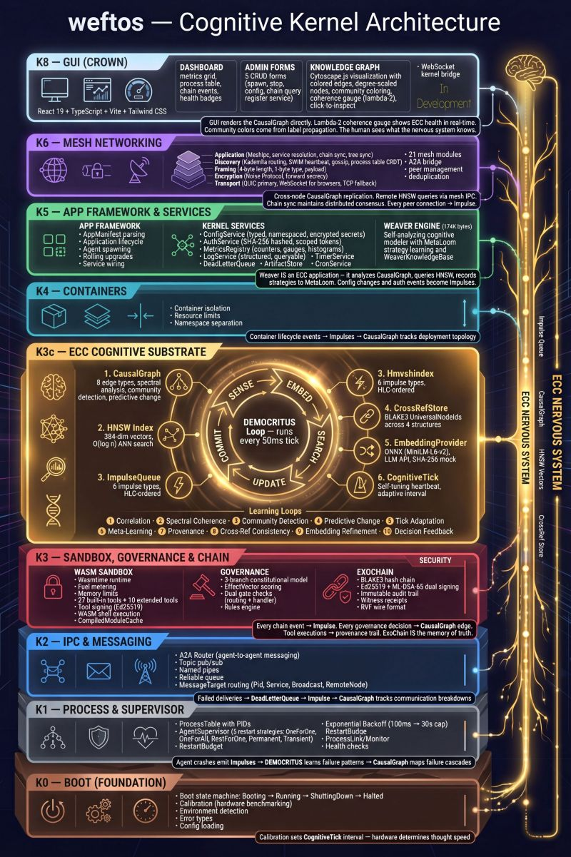

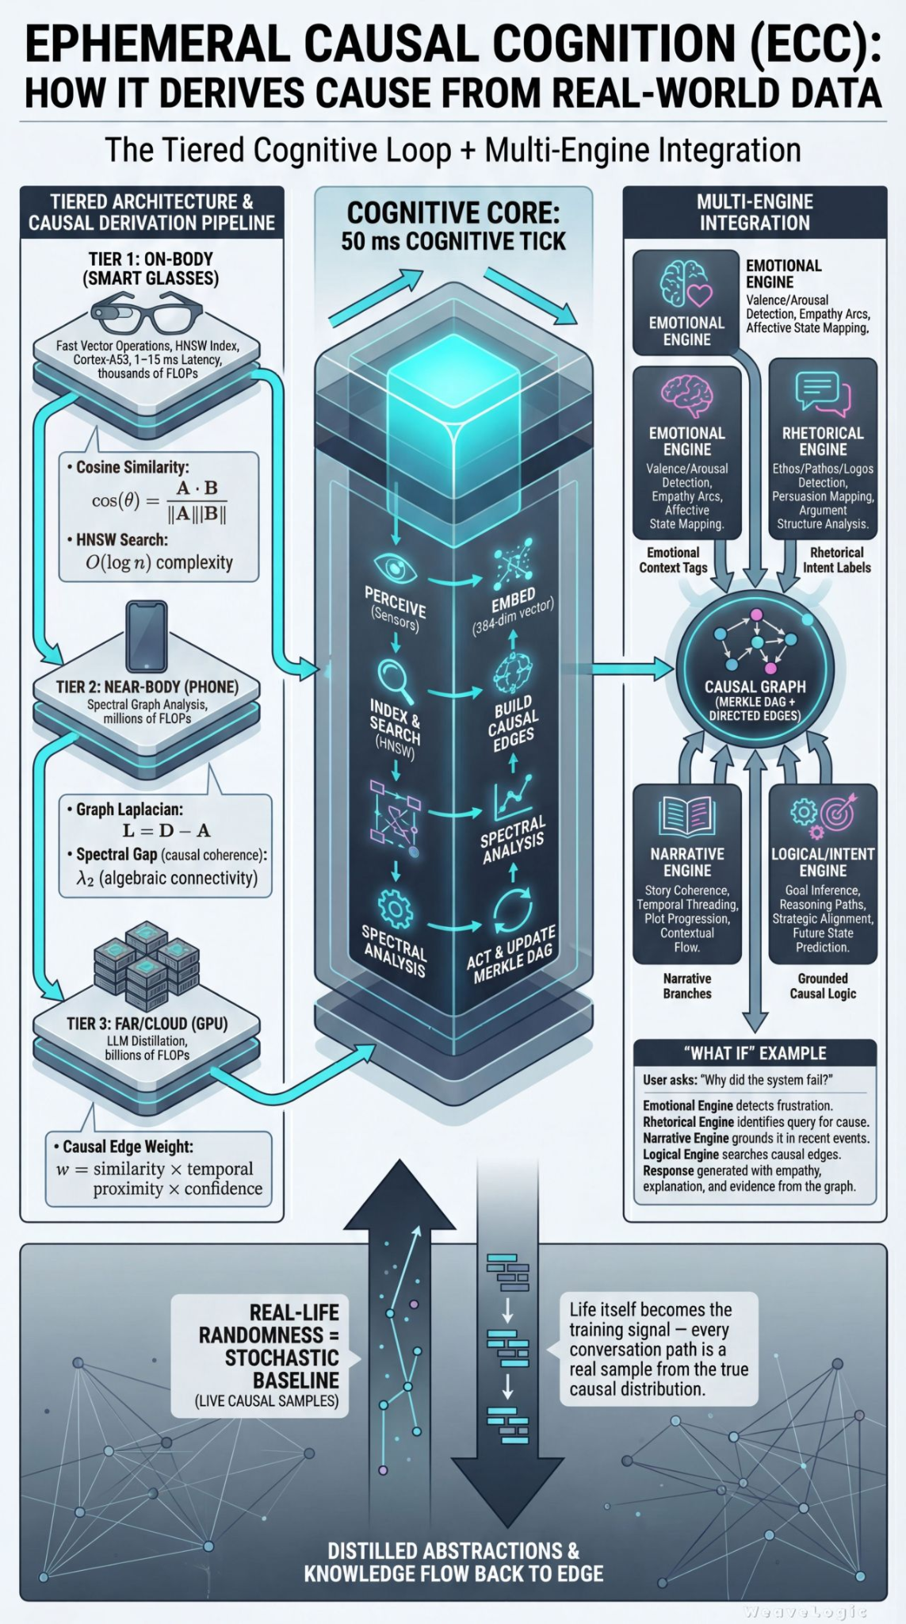

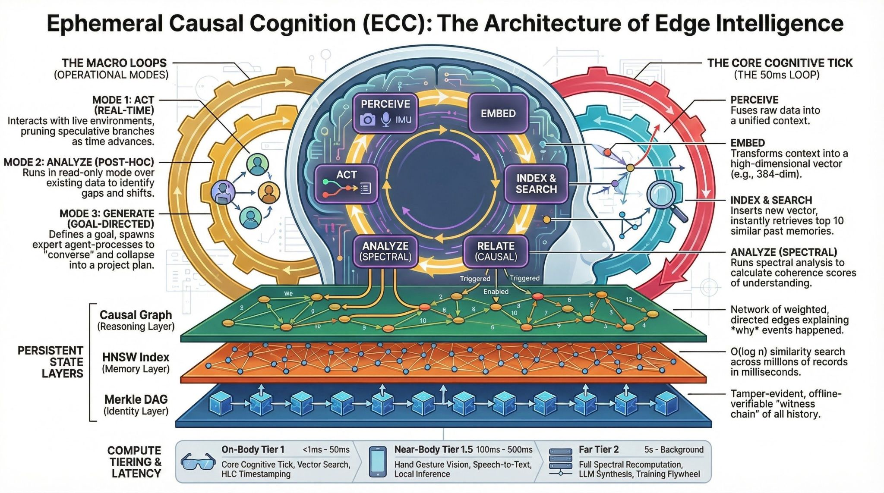

WeftOS: Secure, Ephemeral AI Operating System
WeftOS is a portable AI kernel with process management, mesh networking, and a cognitive substrate built in Rust. It provides a secure, ephemeral AI operating system that replaces cloud-dependent chatbots with a distributed kernel, giving AI agents persistent memory, verifiable reasoning, and constitutional governance. It is designed to run on diverse hardware, from Raspberry Pi devices to browser tabs or air-gapped data centers.

Core Architecture & Capabilities
The WeftOS kernel layer provides essential operating system services including process management with PID allocation and capability-based RBAC, and typed IPC with seven target types. It supports three operating modes: Act (real-time conversation processing), Analyze (post-hoc understanding of corpora), and Generate (goal-directed content generation). Local LLM inference is supported via Ollama, llama.cpp, or vLLM to ensure privacy.

Security and Audit Trail (ExoChain)
Security is centered around an append-only hash chain called ExoChain. Every agent action—including tool calls, IPC messages, and governance decisions—is recorded with SHAKE-256 hash linking and Ed25519 + ML-DSA-65 dual signatures. This creates a verifiable, cryptographic audit trail where any claim an agent makes can be verified.

Mesh Networking (K6)
The Mesh Networking (K6) layer enables encrypted peer-to-peer clusters across heterogeneous devices. It utilizes Noise Protocol encryption and post-quantum protection via hybrid ML-KEM-768 + X25519 key exchange. Key features include transport-agnostic links (TCP, WebSocket, and QUIC-ready), peer discovery via mDNS and Kademlia DHT, and metadata consensus using a Raft-style log or CRDT gossip.

Constitutional Governance
Every privileged operation in WeftOS passes through a three-branch constitutional governance engine:
- Legislative: Defines what agents are permitted to do.
- Executive: Handles runtime approval of actions.
- Judicial: Performs post-hoc audits of system activity.
A 5-dimensional effect vector scores every action based on risk, fairness, privacy, novelty, and security.

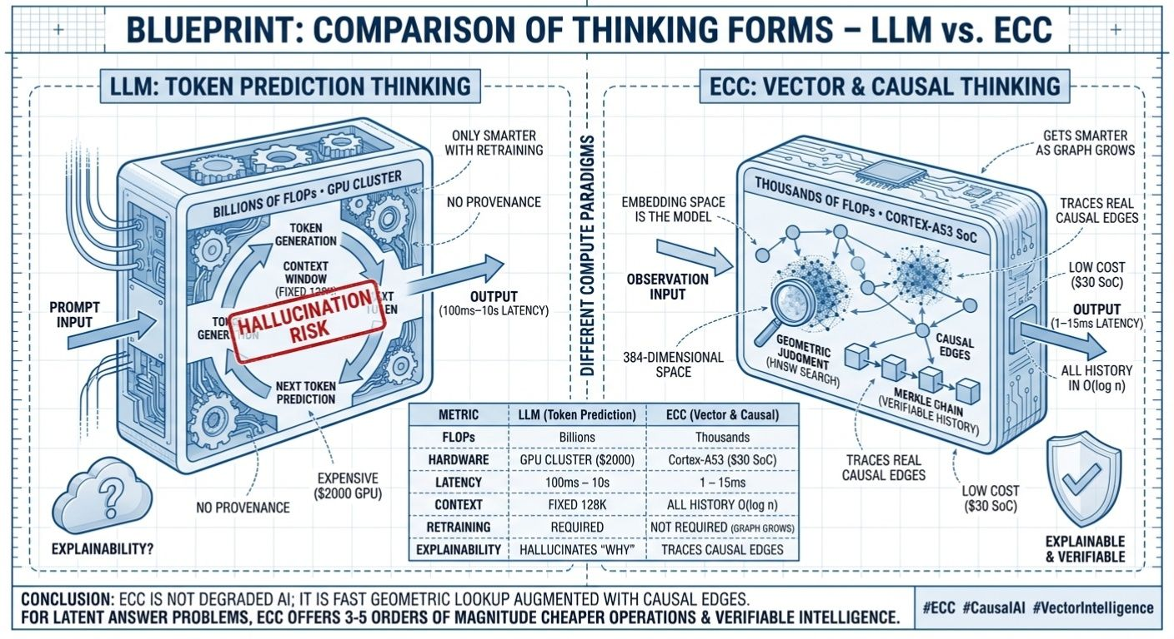

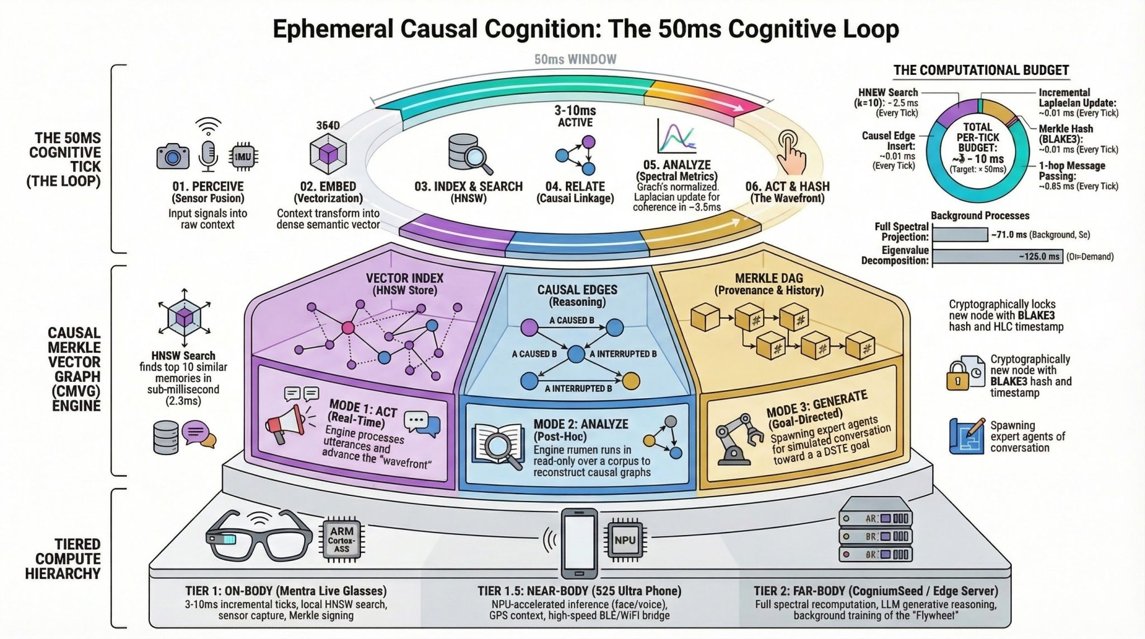

SimpleAgents
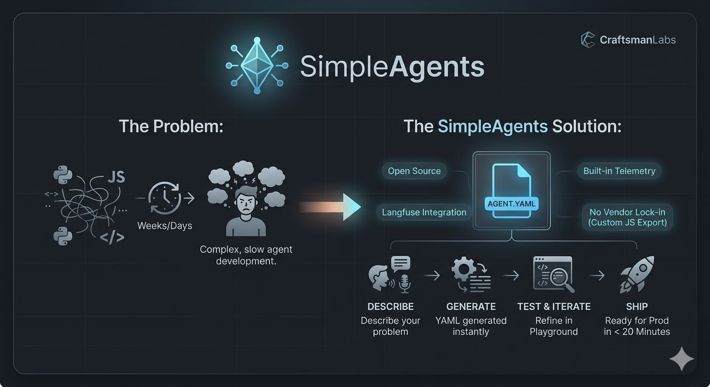
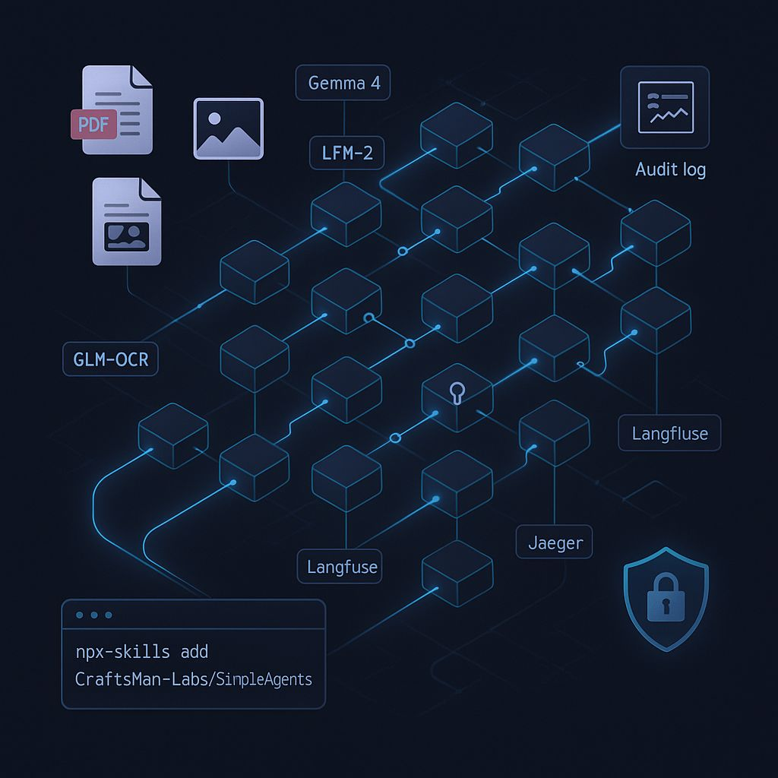

Project Logo
Possible logo to ref for project.



Harware - Not needed Now
# Accelerated Edge AI Hardware Landscape Against a 257‑Core Agentic Chip Target

## Executive summary

A purpose-built “~257-core agentic edge chip” (interpreted as **~256+1 programmable compute tiles plus a controller**, with **~20 MB on-chip SRAM**, and **extreme burst clock near ~8 GHz**) does **not** appear as a disclosed, commercially sold edge-AI accelerator in the sources reviewed. The closest *structural* matches to the **257-ish** concept show up in **many-core research** (notably a **256 RISC‑V core cluster**) and in an older many-core microcontroller pattern (256 PEs + controller), while most **commercial edge AI accelerators** avoid publishing “core count” in a CPU-like sense and instead compete on **TOPS, memory bandwidth, compiler/runtime maturity, and module form factors**. citeturn30view0turn31search12

On the **clock-rate** axis, the “~8 GHz” target is far outside what is publicly documented for today’s edge AI accelerators; even high-end edge inferencing devices typically emphasize **parallelism + data locality** rather than ultra-high single-domain frequency, and commonly published frequencies are in the **sub‑GHz to low‑GHz** range (or not specified at all). In contrast, the strongest edge products differentiate by combining: **(a) dedicated on-device memory**, **(b) weight-stationary / near-memory compute**, and **(c) software stacks that automate quantization + compilation**. citeturn30view0turn19view0turn26view0

If the target is reframed from literal “257 CPU-like cores @ 8 GHz” into a more realistic “~256+ programmable tiles/PEs with an on-chip scratchpad and tensor engines,” then the most compelling *closest matches* split into two groups:

- **Many-core research prototypes nearest the 257-core concept**: **TensorPool** (256 RISC‑V programmable cores + tensor engines, with an on-chip scratchpad) is the most direct modern analogue to “lots of small cores + local SRAM + acceleration.” citeturn30view0
- **Commercial edge accelerators closest to the memory/perf-per-watt intent**: the strongest shipping/for-sale options emphasize **on-chip SRAM (sometimes large), dedicated DRAM (often multi‑GB), and power envelopes from sub‑W to tens of W**, e.g., **Metis M.2**, **Europa**, **Hailo‑10H in Pi HAT+ 2 / USB products**, **EN100**, **DX‑M1**, and **Edge TPU USB**. citeturn19view0turn32view0turn12view0turn20search4turn26view0turn34view0

For *agentic / self-learning* specifically, mainstream edge NPUs are still mostly **inference accelerators**. The clearest “self-learning on-device” direction appears in **neuromorphic/event-driven processors** (e.g., Akida’s on-chip learning claims; Loihi 2’s programmable learning mechanisms), but these are often positioned as **IP / research platforms** rather than mass-market USB dongles. citeturn36search4turn38view0turn38view1

Commercial coverage in this report includes entity["company","Google","technology company"], entity["company","Hailo","edge ai accelerator company"], entity["company","Raspberry Pi","single-board computer maker"], entity["company","ASUS","computer hardware company"], entity["company","Axelera AI","edge ai accelerator company"], entity["company","EnCharge AI","analog in-memory compute company"], entity["company","DEEPX","edge ai chip company"], entity["company","M5Stack","embedded hardware company"], entity["company","Axera Semiconductor","ai soc company"], entity["company","QNAP","nas hardware company"], entity["company","Syntiant","edge ai chip company"], entity["company","Innatera","neuromorphic chip company"], entity["company","BrainChip","neuromorphic chip company"], and entity["company","Intel","semiconductor company"]. citeturn12view0turn7view0turn32view0turn25view0turn26view0turn17view0turn35search0turn23view1turn20search12turn36search4turn38view1

## Target chip profile and matching methodology

The user’s target can be read as a **purpose-built, on-device “agentic” compute substrate** with these anchors:

- **Core count:** ~257 (or nearest). The most literal interpretation is **256 compute elements + 1 controller**—a common pattern in many-core/tiled designs. citeturn30view0turn31search12
- **Architecture:** “agentic” suggests **programmability + autonomy**, with room for **continual adaptation** (fine-tuning, online learning, local planning loops). Mainstream edge NPUs accelerate inference pipelines; only a subset of architectures explicitly foreground on-device learning. citeturn36search4turn38view0turn21search21
- **Clock:** ~8 GHz burst (or nearest). Current edge accelerators rarely publish GHz-class NPU clocks; where frequencies are published, they trend far below 8 GHz. citeturn2view0turn23view1turn26view0
- **On-chip SRAM:** ~20 MB (or nearest). Many edge NPUs rely on some on-chip SRAM (often single-digit MB), and/or lean on **dedicated external LPDDR** for model capacity. citeturn14search1turn2view0turn12view0turn32view0
- **Perf/J:** seek **~10–20×** gain vs “mainstream”. Vendors frequently claim large efficiency deltas; careful comparison requires matching **precision (INT4 vs INT8 vs FP16)** and defining the baseline (CPU vs GPU vs other NPUs). citeturn25view0turn32view0turn26view0

Because “core count” is inconsistent across vendors (CPU cores, NPU “cores,” vector cores, PEs, MAC lanes, tensor engines), this report records:

- **Published compute tile/core counts** when explicitly stated (e.g., “256 RISC‑V cores,” “16 vector cores,” “8 AIPUs,” “192 compute engines”). citeturn30view0turn32view0turn2view0
- **“Not disclosed”** where vendors only publish TOPS and module specs.

## Comparative table of candidates

**How to read the table:**
Core count is shown exactly as published (or closest directly comparable unit such as PEs/compute engines). TOPS/W is included only when it is a direct published metric or a *simple arithmetic implication* from two published numbers (clearly marked as derived). “Agentic/self-learning” is marked **Yes** only when sources explicitly describe on-device learning mechanisms (e.g., on-chip learning, programmable learning rules). citeturn36search4turn38view0

| Candidate (chip / module / product) | Vendor / group | “Core count” (as published) | Architecture type (stated/clear) | Peak performance | Clock / burst | On-chip SRAM (or closest on-chip store) | Power / efficiency | Form factor | Availability | Price (public) | Frameworks / software stack | Programmability | Agentic / on-device learning notes |
|---|---|---:|---|---|---|---|---|---|---|---|---|---|---|
| TensorPool (research many-core processor) | Research (AI‑native RAN) | 256 RISC‑V cores + 16 tensor engines | Many-core + tensor engines + scratchpad | “8 TFLOPS@FP16 peak” (paper) | Not stated in captured excerpt | 4 MiB shared L1 scratchpad | 4.3 W stated; efficiency metrics reported in paper | Research silicon / architecture | Research | — | Research toolchain implied; not productized | Programmable (RISC‑V cores) | Not positioned as “learning,” but a programmable substrate for tensor workloads |
| Metis M.2 AI Inference Acceleration Card | Axelera AI | 1× Metis AIPU (quad-core) | Accelerator (AIPU) + host pipeline | 214 INT8 TOPS | Not disclosed | Not disclosed (uses dedicated DRAM) | Typical app power 3.5–9 W; (derived upper-bound TOPS/W from peak/typical is not a measured metric) | M.2 2280 M‑key, PCIe Gen3 x4 | For sale, backordered | €229.95 (ex‑VAT) | Voyager SDK; compiler supports PyTorch & ONNX; YAML pipeline; GStreamer/inference server integration described | High (SDK + low-level APIs) | Inference-focused; “self-learning” not claimed |
| Europa AIPU | Axelera AI | 8 AIPUs + 16 RISC‑V vector processing cores | Heterogeneous (AIPU + RISC‑V vectors + video decode) | 629 TOPS; INT4/INT8/INT16 | Not disclosed | 128 MB L2 SRAM | 45 W TDP; vendor claims 2–3× perf/W over competition | Chip / PCIe cards (edge-to-server class) | Early access / updates sign-up | Not disclosed | Same Voyager SDK across Metis/Europa | High | Still inference-positioned; on-device “learning” not claimed |
| Hailo‑10H in Raspberry Pi AI HAT+ 2 | Hailo / Raspberry Pi | Not disclosed | NPU accelerator + on-board RAM | 40 TOPS (INT4) | Not disclosed | Not disclosed (8 GB LPDDR4X on-board RAM) | 3 W limit is cited in independent testing; product claims focus on local GenAI | HAT+ (PCIe add-on) | Available (announced “buy now”) | $130 at launch; later product brief lists $180 | Hailo toolchain: Dataflow Compiler; “hailo‑ollama” backend mentioned; Pi camera stack integration described | Moderate via compiler/runtime | Not “online learning,” but supports LoRA adapter workflows (deployment-focused) and model fine-tuning toolchain |
| Hailo‑10H M.2 module (as used in USB products) | Hailo | Not disclosed | NPU accelerator | 40 TOPS (INT4) | Not disclosed | Not disclosed (module pairs with LPDDR4X) | Module brief shows 3 W max; (derived ~13 TOPS/W at INT4 from 40 TOPS/3 W) | M.2 2242 (module) | Commercial module | — | Hailo SDK/compiler ecosystem | Moderate | Inference accelerator; no explicit on-chip learning claim |
| UGen300 USB AI Accelerator 8G | ASUS (uses Hailo‑10H) | Not disclosed | USB accelerator (Hailo‑10H based) | Marketed as up to 40 TOPS | Not disclosed | Not disclosed (8 GB in product SKU) | Not disclosed | USB accelerator | Announced product | Not disclosed | Tied to Hailo software ecosystem | Moderate | Inference accelerator |
| EN100 (analog in-memory compute accelerator) | EnCharge AI | Not disclosed | Analog in-memory compute accelerator | “200+ TOPS” in M.2 form factor (press) | Not disclosed | Not described as SRAM; design is “analog in-memory” | 8.25 W envelope for M.2; company claims “20× higher efficiency (TOPS/W)” vs “industry-leading products” (vendor claim) | M.2 module; multi-chip PCIe card also described | Samples / early access (timing stated as later in year in 2025 reporting) | Not disclosed | “Flexible software” positioning; details not fully public on the main page | Unknown | Not positioned as on-chip learning; focuses on efficient inference |
| DX‑M1 (chip and M.2 module ecosystem) | DEEPX | Not disclosed | NPU accelerator (with external LPDDR) | 25 TOPS (INT8) | Not disclosed | Not disclosed | 1–5 W power consumption stated; vendor claims “~20×” efficiency vs GPGPUs | M.2 modules and chips | Commercial product line | Not disclosed | Supports Ultralytics / TensorFlow / PyTorch / ONNX / Keras; Windows + Linux + Yocto + Docker | Moderate | Inference accelerator |
| LLM‑8850 Kit (AX8850 M.2 + PiHat) | M5Stack / Axera | 8× Cortex‑A55 CPU cores (SoC); NPU “cores” not disclosed | SoC (CPU + NPU + video engines) | 24 TOPS (INT8) | CPU 1.7 GHz stated | Not disclosed (8 GB LPDDR4x on module) | Card power 7 W @ 3.3 V stated | M.2 2242 + adapter (PiHat) | Commercial kit (often out of stock) | $215 listed for kit | “AXCL” one‑click deployment claim; supports CNN/Transformer/VLM/LLM examples in docs | Moderate (SoC + stack) | Inference + system integration; no explicit on-chip learning claim |
| Coral USB Accelerator (Edge TPU) | Google | Not disclosed | Edge TPU ASIC for TFLite | 4 TOPS (INT8) | “Max clock is 2× reduced”; absolute MHz/GHz not published | 6.91 MiB on-chip parameter cache available reported by compiler; Google blog references 8 MB cache | 2 W for 4 TOPS = 2 TOPS/W stated | USB 3.0 Type‑C device | Commercial product | Not disclosed in datasheet | TensorFlow Lite, Edge TPU runtime/API; host OS support listed | Low–moderate (compile constraints) | Inference; no on-chip learning |
| QAI‑U100 (Edge AI Accelerator for NAS) | QNAP | Not disclosed (CPU: dual Cortex‑A35) | USB NPU accelerator (RK1808 based) | Up to 3 TOPS | CPU 1.6 GHz stated | Not disclosed (1 GB memory stated) | Not disclosed; positioning: offload CPU | USB‑A 3.2 Gen1 stick | Commercial | $69 shown by a major retailer listing | Requires QTS/QuTS + QNAP AI Core and apps (QuMagie etc.) | Low (appliance-like) | Inference; no learning |
| NDP250 Neural Decision Processor | Syntiant | Not disclosed | At-memory / low-power edge AI SoC + DSP + MCU | “>30 GOPS” in product/press materials | Up to 120 MHz internal | 1.5 MB SRAM (HiFi 3 DSP) + 512 KB SRAM (Cortex‑M0) | Power envelope “10–100 mW” reported; targets always-on | Chip/package | Sampling announced; commercial availability depends on design-ins | Not disclosed | SDK + Training Dev Kit; states TensorFlow for customer-programmed apps | Moderate for embedded | Intended as always-on assistant/wake & multimodal pre-processing versus full on-device learning |
| Pulsar neuromorphic MCU | Innatera | Not disclosed | Mixed-signal neuromorphic MCU (SNN) | Not in TOPS; targets sensing workloads | Not disclosed | Not disclosed | Example power: 400–600 µW for specific tasks; claims extreme energy reduction | MCU (integrated) | “Launch” announced; positioned as commercially available | Not disclosed | Talamo stack described as interfacing with PyTorch | Moderate (via Talamo) | Neuromorphic approaches can enable adaptive behavior; explicit “learning” details depend on model/tooling |
| Akida (neuromorphic/event-based) | BrainChip | Example chip described with 80 NPUs (older article); Akida 2 marketed as IP | Event-based processor; neuromorphic + deep learning | Not in TOPS in cited sources | Not disclosed | Not disclosed | Emphasis: edge efficiency and on-chip learning; no TOPS/W number in cited pages | IP / silicon / partner products | Commercial IP positioning | Not disclosed | Marketed: on-chip learning; supports event-based nets | Higher than typical NPUs (in concept) | Explicitly markets “one-shot/few-shot” on-chip learning |
| Loihi 2 (neuromorphic research platform) | Intel | Up to 128 neuron cores + 6 embedded microprocessor cores | Neuromorphic manycore + programmable learning | Not in TOPS; capacity metrics given | Not disclosed | Per-core synaptic memory up to 128 KB; flexible memory allocation in brief | Research focus: efficiency & learning mechanisms | Research chip + boards | Research ecosystem | — | Programmed with conventional code for I/O and management; learning rules supported | High for neuromorphic workflows | Explicit programmable learning rules and three-factor traces |

**Primary sources used for table facts** include vendor product briefs/pages and official technical briefs: Metis product brief & store listing citeturn19view0turn17view0; Europa product page citeturn32view0; Raspberry Pi AI HAT+ 2 launch post and Hailo blog citeturn12view0turn11search10; Hailo‑10H module brief screenshots citeturn7view0turn7view1; Coral USB Accelerator datasheet and compiler memory doc citeturn34view0turn14search1; QAI‑U100 product/spec pages and announcement citeturn35search0turn35search2turn35search3; NDP250 product brief & reporting citeturn23view1turn21search21; Innatera launch reporting and edge-chip roundup citeturn20search12turn20search15; Akida IP page and referenced PDF snippet citeturn36search4turn36search32; Loihi 2 technical brief screenshots and Intel research page citeturn38view0turn38view1turn36search9; TensorPool paper citeturn30view0; MemryX MX3 datasheet citeturn2view0; DeepX DX‑M1 product page citeturn26view0; EnCharge claims and announcement citeturn25view0turn20search4turn20search23; M5Stack LLM‑8850 kit docs and store listing citeturn27view0turn28search6.

## Key candidates by architecture class

A useful way to map the field to your “257‑core agentic chip” target is to treat it as a **three-way balance**:

1) **Programmability per compute element** (agentic loops, autonomy, custom kernels)
2) **Data locality** (SRAM/scratchpad, avoiding off-chip traffic)
3) **Task type** (dense GEMM, sparse/event-driven sensing, or mixed pipelines)

Below is a compact architecture map plus “tell-it-like-it-is” implications.

```mermaid
flowchart LR
A[Agentic on-device autonomy] --> P[Programmable many-core + scratchpad]
A --> N[Neuromorphic / event-driven learning]
A --> I[Inference-first NPU + dedicated DRAM]

P --> TP[TensorPool-style 256-core cluster]
N --> AK[Akida]
N --> LO[Loihi 2]
I --> HX[Hailo-10H products]
I --> AM[Metis / Europa]
I --> EC[EN100 analog in-memory]
I --> DX[DX-M1 class NPUs]
I --> TPU[Edge TPU USB]

U[USB form factor] --> TPU
U --> QAI[QAI-U100]
U --> UGEN[UGen300]
```

This mapping is grounded in the vendors’ disclosed architectures and positioning: TensorPool’s 256 RISC‑V core cluster citeturn30view0; Loihi 2’s 128 neuron cores + 6 embedded processors and programmable learning citeturn38view0turn38view1; Akida’s on-chip learning marketing citeturn36search4; Europa’s heterogeneous “AIPUs + RISC‑V vectors + 128MB SRAM” citeturn32view0; Metis’ 214 TOPS M.2 card and software stack citeturn19view0turn19view1; Hailo‑10H “GenAI Pi” positioning with 8GB RAM citeturn12view0turn11search10; EN100’s analog in-memory claims citeturn20search4turn25view0; DX‑M1’s 1–5W, 25 TOPS positioning citeturn26view0; and USB accelerator specs for Edge TPU and QAI‑U100 citeturn34view0turn35search0.

image_group{"layout":"carousel","aspect_ratio":"16:9","query":["Raspberry Pi AI HAT+ 2 Hailo-10H board photo","Google Coral USB Accelerator Edge TPU photo","ASUS UGen300 USB AI Accelerator photo","QNAP QAI-U100 USB edge AI accelerator photo"],"num_per_query":1}

### Many-core programmable clusters nearest “257 cores”

**TensorPool** is the standout “nearest neighbor” to your core-count target because it is explicitly a **256-core programmable cluster** with **local scratchpad memory**, plus tensor engines for GEMM-heavy workloads—conceptually aligned with a “many small agents/cores cooperating” substrate. It is also explicit about **edge-like power** (single-digit watts) in its reported instance. citeturn30view0

The blunt constraint: TensorPool’s disclosed scratchpad in the excerpt is **4 MiB**, far below your **~20 MB SRAM** target, and the paper emphasizes AI-native RAN workloads rather than general edge agentic stacks. That said, it provides a concrete modern template for “256 programmable cores + shared SRAM + tensor offload.” citeturn30view0

A historical “256 + controller = 257” pattern exists (e.g., older Kilocore-style descriptions), reinforcing that the **257 number often means “tile array + management core”**, but those examples are not modern edge-NPU products and are largely historical references rather than current commercial offerings. citeturn31search12turn31search10

### Inference-first “NPU + dedicated DRAM” platforms closest to the intent

If the practical goal is “self-contained intelligence in a device,” the strongest commercial direction today is **NPU + multi‑GB on-module LPDDR**, because this directly addresses the *model-size bottleneck* that small SRAM-only accelerators hit.

- The Raspberry Pi AI HAT+ 2 pairs **Hailo‑10H** with **8 GB on-board RAM** and positions itself explicitly for **local LLM/VLM workloads**. It is also integrated with a developer-facing toolchain (compiler + an Ollama backend mentioned) and is stated as purchasable at launch, with pricing that appears to have shifted between launch post and later product-brief list price. citeturn12view0turn11search10turn8view0
- In a different performance class, **Europa** makes an aggressive “data locality” move by integrating **128 MB L2 SRAM** on-chip (well above your 20 MB target) and adding **RISC‑V vector cores** so that pre/post processing can be on-die rather than on the host CPU. This is a “heavy edge / edge server” posture rather than a low-power dongle. citeturn32view0
- **Metis** is the more compact “classic edge M.2 accelerator” approach: a PCIe M.2 card with **214 INT8 TOPS** and **3.5–9W typical application power**, plus an SDK focused on rapid deployment and model compilation from standard frameworks. citeturn19view0turn19view1

### USB accelerators: ubiquitous, but rarely “agentic”

USB dongle accelerators succeed on **simplicity and deployment**, not on “agentic programmability.”

- The **Coral USB Accelerator** (Edge TPU) is explicit: **4 TOPS** at **2 W** (2 TOPS/W), across Linux/macOS/Windows hosts, but it is compilation-constrained and its usable on-chip parameter cache is single-digit MiB. citeturn34view0turn14search1
- The **QAI‑U100** is even more appliance-like: **3 TOPS**, **1 GB memory**, targets QNAP NAS photo/video recognition pipelines and requires QNAP OS/app versions. citeturn35search0turn35search2turn35search3

USB form factors are therefore great “bolt-on inference,” but they generally do not resemble a **257‑core autonomous compute island**.

### Neuromorphic/event-driven chips: closest to “self-learning” semantics

If “agentic” is taken literally as **on-device adaptation** (few-shot/online learning, event-time memory updates), the closest documented direction is neuromorphic/event-driven hardware:

- **Akida** explicitly markets **on-chip learning**, including “one-shot/few-shot learning,” in its IP descriptions. citeturn36search4
- **Loihi 2** is explicit about **programmable learning** mechanisms and architecture built around many neuromorphic cores and embedded microprocessor cores; its brief shows **up to 128 neuron cores** and **6 processors**, and highlights learning architecture evolution. citeturn38view0turn38view1

The reality check: these platforms are not described as USB dongles for mass consumers in the cited sources; they function more as **research ecosystems / IP blocks / specialized deployments**. citeturn36search9turn36search4

## Patents and research threads most relevant to a 257‑core edge agentic design

This section curates patents and papers that map directly onto your target attributes: **(a) systolic/array compute**, **(b) compute-in/near-memory**, **(c) many-core programmability**, and **(d) on-device learning**.

### Systolic arrays and array-based neural processing patents

Multiple foundational patent families describe neural network accelerators built around **systolic arrays of processing elements**, often with an external controller/microprocessor orchestrating computation—structurally consistent with “many PEs + controller.” Examples include:

- A “one dimensional systolic array architecture for neural network” (processing elements in a systolic chain controlled by a microprocessor). citeturn36search2
- Systolic-array neural processor disclosures in later families (e.g., “neural network processor” descriptions referencing systolic array computation). citeturn36search14turn36search18
- Earlier “two-dimensional systolic array for neural [networks]” style disclosures (array of PEs supporting multiple network modes). citeturn36search10

**Implication for your target:** a “257 core” edge accelerator can be credibly interpreted as a **systolic/tiled array** where the visible “core count” is the PE grid (e.g., ~256) plus a controller, rather than 257 out-of-order CPUs.

### Compute-in-memory and analog in-memory computing patents

Compute-in-memory (CiM / IMC) patent families focus on placing MAC operations *where the weights live*, directly pulling toward your **perf/J** goal (reducing data movement across the memory hierarchy):

- A patent describing **in-memory multibit analog computing** techniques (memory arrays + analog conversion networks for IMC). citeturn36search11
- A mapping-focused disclosure for **3D analog in-memory computing** (addresses how to utilize analog IMC fabric efficiently). citeturn36search15
- “Scalable array architecture for in-memory computing” describing an array of compute-in-memory units interconnected by an on-chip network—conceptually aligned with multi-core/tile fabrics. citeturn36search31
- A more recent IMC architecture disclosure describing adaptation to scalable neural network accelerators. citeturn36search7
- A representative IMC accelerator method/patent describing SRAM-array-based inner-product accumulation in an IMC unit. citeturn36search3

**Connection to commercial EN100 claims:** EnCharge positions EN100 as “analog in-memory computing” and makes explicit efficiency claims (e.g., “20× higher efficiency” on its site) while announcing an M.2 module at **200+ TOPS in an 8.25 W envelope**. citeturn25view0turn20search4turn20search23

### Recent academic work tying “many-core + local SRAM” to edge-scale power

The most direct academic correspondence to “~257 cores + local SRAM” in this dataset is TensorPool’s explicit **256 RISC‑V programmable cores** with **an on-chip scratchpad** and added tensor engines, positioned against power constraints compatible with edge deployments (in its target domain). citeturn30view0

Separately, recent edge-accelerator research continues to explore systolic-array design tradeoffs for edge workloads (e.g., “design-space exploration of systolic arrays for edge” work), reinforcing that the hardware community still treats systolic/array accelerators as the core primitive for edge efficiency. citeturn14search11

### On-device learning and “agentic” behavior: neuromorphic as the most explicit match

Two sources in particular are explicit about **learning mechanisms** in silicon:

- Loihi lineage: “Loihi: a neuromorphic manycore processor with on-chip learning” (paper positioning) and Loihi 2’s technical brief describing learning architecture and programmable mechanisms. citeturn36search21turn38view1
- Akida positioning: marketing IP page claims “On-Chip Learning” including one-shot/few-shot learning; separate material describes Akida as event-based and self-contained. citeturn36search4turn36search0

For an “agentic chip” premise—especially if “self-learning” is central—these are the sources that most directly align with the requirement in a literal way.

## Conclusions and design implications for a “257‑core agentic edge chip”

### What matches well today

- **Core-count nearest match (modern):** The closest *explicit* modern analogue to “~256+ cores” is the **256-core programmable cluster** pattern in current research (TensorPool). citeturn30view0
- **On-chip SRAM nearest match (commercial):** Europa’s published **128 MB L2 SRAM** overshoots your 20 MB SRAM goal but demonstrates the direction: brute-force locality can be a core differentiator. citeturn32view0
- **Developer-accessible edge GenAI add-ons:** Hailo‑10H products (Pi HAT+ 2, modules used in USB products) illustrate the “edge GenAI expansion card” pattern: combine an accelerator with **multi‑GB on-board RAM** so small LLMs can run locally. citeturn12view0turn7view0
- **Best “bolt-on inference” simplicity:** Edge TPU USB remains a clean reference implementation for a low-power USB accelerator with published perf/W figures and strong TFLite tooling. citeturn34view0turn14search1

### Where the target is not currently mirrored by known offerings

- **~8 GHz burst frequency:** No reviewed edge NPU/USB accelerator close to this published figure; modern approaches trade frequency for **parallelism and locality**. citeturn2view0turn23view1turn30view0
- **“257 cores” as a standard commercial spec:** Most commercial edge accelerators publish **TOPS**, not PE/“core count,” and where “cores” are published they are typically CPU/vector cores on the side (e.g., Europa’s 16 RISC‑V vector cores), not hundreds of agent-like cores. citeturn32view0turn26view0
- **Self-learning intelligence inside mainstream edge NPUs:** Outside neuromorphic/event-based platforms, “learning” is generally handled as **offline training + compile + deploy**, with limited on-device adaptation support. citeturn36search4turn12view0turn19view1

### A forward-looking synthesis grounded in what exists

If you want a design that *most closely approximates* your target while remaining consistent with what current hardware proves feasible, the convergent blueprint supported by the sources is:

- **~256 programmable tiles/PEs + tensor engines** (many-core style) for “agentic” flexibility, as demonstrated by the TensorPool-like pattern. citeturn30view0
- **Tens-of-MB on-chip SRAM** (or a large SRAM tier like Europa’s 128MB) to keep models/activations local and avoid DRAM bandwidth bottlenecks. citeturn32view0
- **Optional dedicated multi‑GB LPDDR on-module** if small LLM/VLM capacity matters more than pure SRAM locality (Pi AI HAT+ 2 approach). citeturn12view0turn7view0
- **A compiler-driven software stack** that treats the accelerator as a deploy target (Metis Voyager, Hailo toolchain, Edge TPU compiler constraints), because software friction—not TOPS—often decides real adoption. citeturn19view1turn11search10turn14search1

### Selected milestone timeline

```mermaid
timeline
title Selected edge AI accelerator milestones relevant to “257-core agentic” targets
2024-04 : NDP250 announced (always-on, low-power edge AI)
2025-05 : EN100 announced (analog in-memory compute, M.2 form factor)
2025-05 : Pulsar launch announced (neuromorphic MCU for sensor edge)
2025-07 : QAI-U100 announced (USB NAS-focused NPU accelerator)
2025-10 : Europa announced (large on-chip SRAM + mixed processing)
2026-01 : Raspberry Pi AI HAT+ 2 announced (Hailo-10H + 8GB RAM)
2026-02 : Coral NPU open-source datasheet updated (RISC-V C-programmable NPU IP)
2026-04 : TensorPool paper posted (256-core programmable cluster + tensor engines)
```

Timeline citations: NDP250 disclosures citeturn21search3turn23view1; EN100 announcement citeturn20search4turn20search23; Pulsar launch citeturn20search12turn20search15; QAI‑U100 announcement citeturn35search3; Europa announcement/product positioning citeturn16search0turn32view0; Raspberry Pi AI HAT+ 2 launch citeturn12view0; Coral NPU datasheet update citeturn15view0; TensorPool posting citeturn30view0.

Tab 10
https://github.com/DavisPL/lhs
https://github.com/crespum/edge-ai
https://hailo.ai/
ESP32 + external memory / accelerator / Edge AI hardware (systolic / ASIC / USB accelerators)
https://github.com/Seeed-Studio

Cognitum Seed is a credit-card-sized device that runs the full Cognitum Agentic OS. Plug it into any USB port and you get 100K+ vector storage, <30ms similarity search, Ed25519 tamper-proof security, 63+ API endpoints, and 12 MCP tools — no cloud, no subscriptions.

Cognitum v1 Chip
The Foundation
At the base of everything is the Cognitum v1 — a purpose-built 257-core agentic chip designed to put self-learning intelligence into any device. Ultra-low power, ultra-low cost. 257 cores, ~8 GHz burst clock, 20 MB SRAM, 10-20x perf/joule gain
Built as a self-contained appliance using a fabric of 7 low-power agentic compute tiles.
7
STM32N645 tiles
Cortex-M55 @ 800 MHz
4,200
GOPS total
600 GOPS/tile NPU
29.4 MB
SRAM
4.2 MB/tile
<15W
Total power
GbE switch included
Key Features
7 compute kernels, ~645 ticks/sec
<1ms tick latency (p95)
Byzantine fault tolerance: 3/7 tiles
Coherence Gate FSM (4 states)
GbE mesh interconnect

Cognitum v1
Low-power intelligence in everything
A purpose-built 257-core agentic chip. Ultra-low power, ultra-low cost — designed to put self-learning intelligence into everything, everywhere.
257
cores per chip
A2S v2r3 ISA, VLIW 4-wide
~8 GHz
burst clock
Dynamic scaling from idle
20 MB
SRAM per chip
80 KB/core
8
coprocessors/core
Root-of-Trust, PUF, AES, GCM, SHA, TRNG
Key Features
257-core agentic ASIC with event-gated execution
Dynamic clock scaling from 0 to ~8 GHz burst on attention
Raceway interconnect (2 TB/second bandwidth)
10–20x improvement in performance per joule
Ultra low cost
Pricing coming soon

https://www.seeedstudio.com/blog/2025/07/30/meet-seeed-studio-xiao-nrf54l15-sense-the-ultra-low-power-platform-with-multi-protocol-connectivity/



MVP2_User Journey
User Journey

